# Login Use Case Diagram

## Section 1: The Primary Presentation

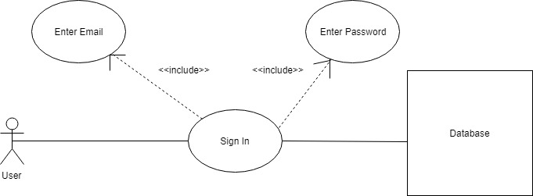

## Section 2: The Element Catalog

### 2.1 Elements and their properties

The stick-figure element represents an actor, from which the use case is initiated. Each oval represents a use case, which is a specific situation for which the product can be used. Lastly, there is the database element, which participates in the action by providing data back.

### 2.2 Relations and their properties

Solid lines represent associations, by which the elements are joined. The segmented lines represent the inclusion of separate use cases, within others.

## Section 3: Context Diagram

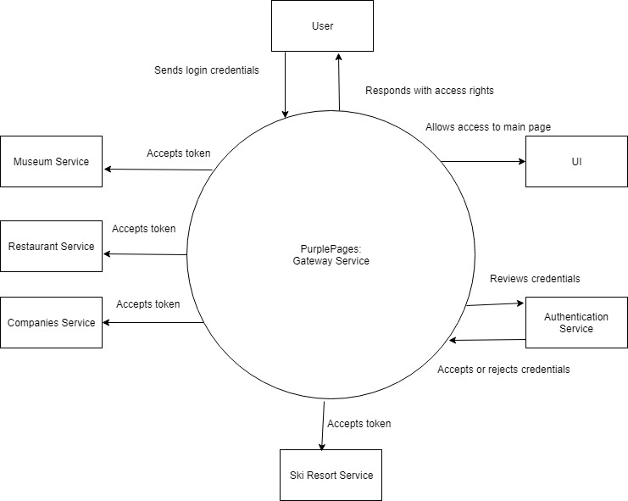

## Section 4: Variability Guide

There are no variation points for this diagram.

## Section 5: Rationale

This diagram demonstrates a standard login procedure. Two forms of data are required to validate a user, in this case, an email to identify the user and a password to confirm the identity. This information is then validated server side to prevent unapproved access.